Question 1)

First Four Digits of Student Id: 3017

Question 2)

Binary Representation Of the Student Id:

b1= 0011

b2= 0000

b3= 0001

b4= 0111

Question 3)

Sum of b1,b2,b3,b4…

sum a1 = 01011

Question 4)

C1 = b2 = 0000

C2 = b3 = 0001

Question 5)

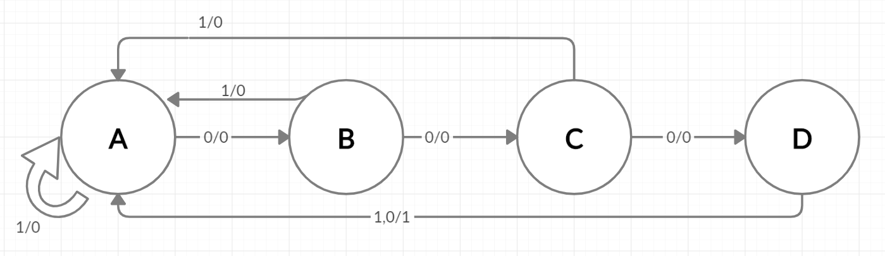

Question 6)

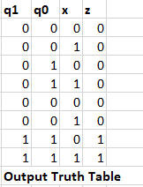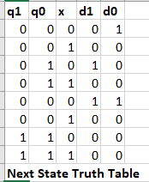

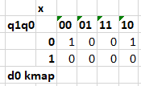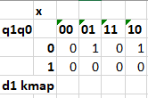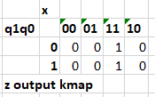

Z = q1q2

d1 = q1 !q0 x + !q1 q0 !x

d0 = !q0 !x

Question 7)

Didn’t have time to do this or the circuit for number 6 due to some work (I work as a developer) projects that came up. You know for work I do stuff that is actually programming, like modern day programming, not time wasters like this entire class of irrelevant material. Unfortunately taking an L on this time waster here.

Question 8)

